

**CI6225 – Enterprise Application Development**

**Individual Assignment 2**

**Deployment Manual**

**Travel Expense Reimbursement Application**

**V2.0**

|  |
| --- |
| SU SHIJIAN (GXXXXXXXX) |

12 Apr 2014

Contents

1. Introduction 3

2. Test Account, Password and Environment 3

2.1 Database Connection 3

2.2 Application Test User Account 3

2.3 Deployment Short Cut 4

2.4 Server Environment 4

2.5 Development Environment 4

3. Configuration and Deployment Steps 5

3.1 Download Relative Software 5

3.1.1 JDK 5

3.1.2 JBOSS AS 5

3.1.3 MySQL Server 5

3.1.4 MySQL Workbench 5

3.1.5 Eclipse 5

3.2 JDK Installation 5

3.3 Database Installation and Import Dump Data 6

3.4 Application Server Installation 7

3.5 Deployment for WAR 8

3.6 Run Application Server 12

4. Validation 14

# 1. Introduction

To deploy the application successfully, you may need to go through below steps. Please base on your actually environment and configuration, to ignore the steps if your prepared.

# 2. Test Account, Password and Environment

## 2.1 Database Connection

Please go to source code, the file store database connection information is:

*ntu-is-ead-tera-v2\WebContent\WEB-INF\classes\hibernate.cfg.xml*

Below screen shoot indicate the place of user name and password.

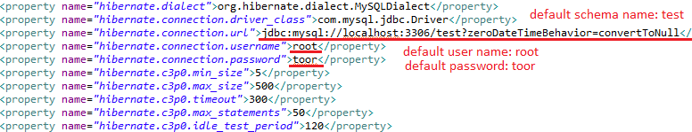

Default Connection URL:

*jdbc:mysql://localhost:3306/test?zeroDateTimeBehavior=convertToNull*

Default Schema Name:  *test*

Default User Name:  *root*

Default Password:  *toor*

## 2.2 Application Test User Account

There are types of user in this application:

1) Normal User:

All users are belonging to normal user.

2) System Administrator:

In “maintain user” edit user model, if “is Administrator” flag is Y, then this user is an administrator user.

3) Department Manager:

In “maintain department” edit department model, if user assigned to “Manager”, then this user is a department manager. The manager depend department; each department only can have one manager.

4) Finical Department User:

In “maintain department” edit department model, if user assigned to a department, which its “Operation Area” is with “is Financial” flag Y, then this user is account user.

Some testing accounts are as below:

|  |  |  |  |  |  |
| --- | --- | --- | --- | --- | --- |
| User  Name | Password | Is Normal  User | Is System Administrator | Is Department  Manager | Is Finical Department User |
| isadmin | root | Y | Y | Y | N |
| account-user1 | root | Y | N | N | Y |
| account-user2-manager | root | Y | N | Y | Y |

*PS: all users’ information is in MySQL database table: users

## 2.3 Deployment Short Cut

As this application does not depend on application server data source, so the short cut to deploy the application, you only need to execute below steps:

1) Copy or deploy WAR into your application server, take JBoss as example, you copy the WAR to “JBOSS folder”\standalone\deployments

2) Start application server

3) Access URL <http://localhost:8080/ntu-is-ead-tera-v2/> to verify with above 2.2 test user account.

## 2.4 Server Environment

|  |  |
| --- | --- |
| Operation System | Windows 7 Service Pack 1 32 bit |
| Java Development Environment | JDK 1.7.0.10 |
| JavaEE Application Server | JBOSS AS 7.1.1.Final |
| Database Server | MySQL Community Server 5.6 |

## 2.5 Development Environment

|  |  |
| --- | --- |
| Operation System | Windows 7 Service Pack 1 32 bit |
| Java Development Environment | JDK 1.7.0.10 |
| Programming Editor | Eclipse (Eclipse IDE for Java EE Developers) |
| Database Client | MySQL Workbench 6.0 |
| Web Browser | Firefox 27.0.1 |

# 3. Configuration and Deployment Steps

## 3.1 Download Relative Software

### 3.1.1 JDK

Version: 1.7.0.10 or above

URL: <http://www.oracle.com/technetwork/java/javase/downloads/index.html>

### 3.1.2 JBOSS AS

Version: 7.1.1.Final

URL: <http://www.jboss.org/jbossas/downloads>

### 3.1.3 MySQL Server

Version: Community Server 5.6

URL: <http://dev.mysql.com/downloads/mysql/>

### 3.1.4 MySQL Workbench

Version: 6.0

URL: <http://dev.mysql.com/downloads/tools/utilities/>

### 3.1.5 Eclipse

Version: Eclipse IDE for Java EE Developers

URL: <https://www.eclipse.org/downloads/index-developer.php>

## 3.2 JDK Installation

**Step 1:** To install JDK

If downloaded .exe version for Windows, double click and follow the instruction to install the JDK. If downloaded .unzip version, after unzip the file, need to manual set up Environment Variable at Windows:

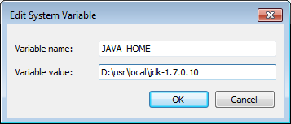

Verify whether %JAVA_HOME%\bin is in Path, if not, add it in.

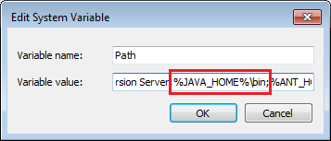

**Step 2:** Verify installation

Open command line, key in:

java -version

And you should see below message:



## 3.3 Database Installation and Import Dump Data

**Step 1:** To install MySQL Server.

Double click and and follow the instruction to install the MySQL Community Server. You can key in “toor” as administrator password.

**Step 2:** To install MySQL Workbench.

Double click and and follow the instruction to install the MySQL Workbench.

**Step 3:** To Import Dump data.

After installed MySQL Server and MySQL Workbench, open MySQL Workbench, to connect database server.

Select Schema “test”

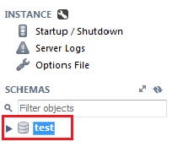

Click “Data Import / Restore”, then select “Import from Self-Contained File” and locate to the Dump.sql file. Then click “Start Import”

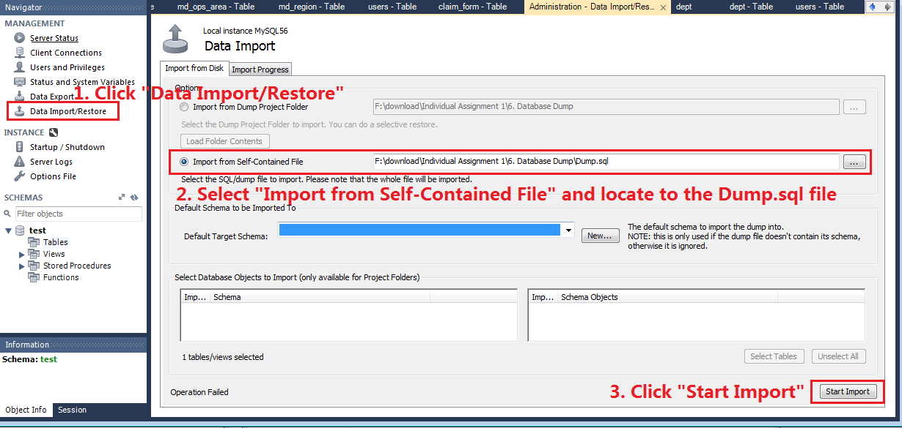

**Step 4:** Here is a screen shot after import completed

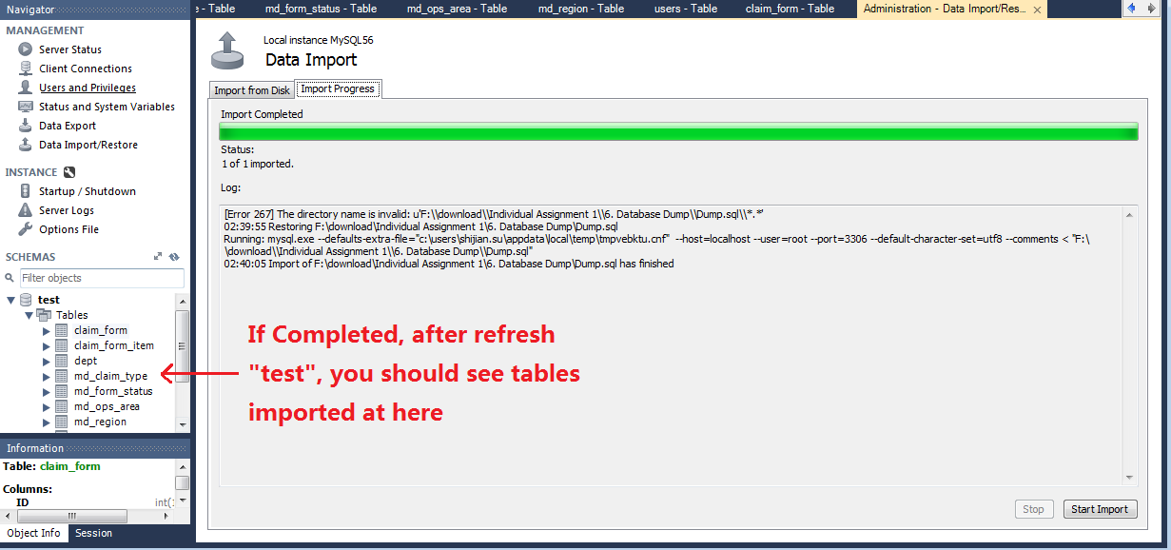

## 3.4 Application Server Installation

**Step 1:** To install JBOSS.

Unzip JBOSS .zip file to your local. After unzip the folder structure is as below:

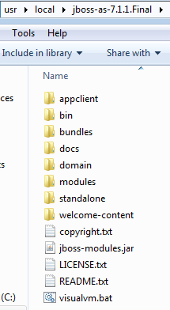

## 3.5 Deployment for WAR

*PS: you can directly use WAR in “7. Deployment WAR” deploy to your application server. Then no need below steps package from source code.

**Step 1:** To install Eclipse (Spring Tool Suite)

Unzip Spring Tool Suite to your local

**Step 2:** To install JBOSS AS plugin

Open Spring Tool Suite, select menu -> Help -> Eclipse Marketplace

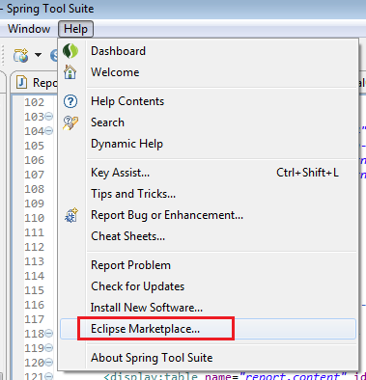

Search by key word “jboss”, and click install from JBoss Tool“

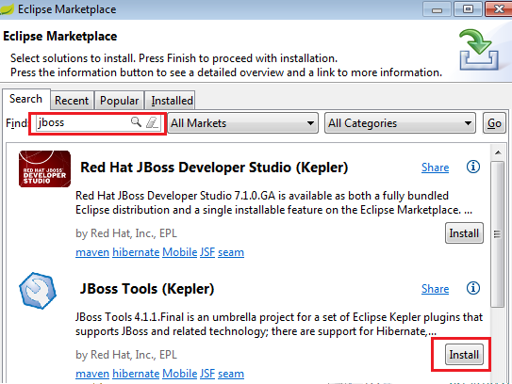

Select the “JBossAS Tools”, and follow the instruction to install the plugin

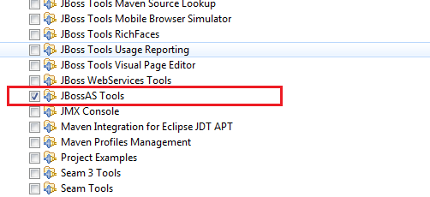

**Step 3:** To configure JBOSS runtime environment in Eclipse

Click menu -> Window -> Preferences, after that, select “Runtime Environment”, and click “Add”

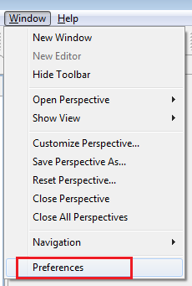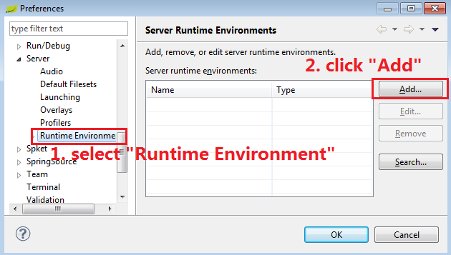

Select JBoss Community -> JBoss 7.1 Runtime

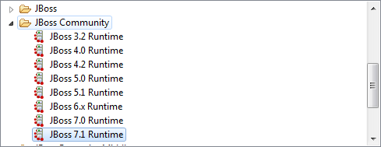

Then select your JBOSS installation location, and click OK/finish to complete the action

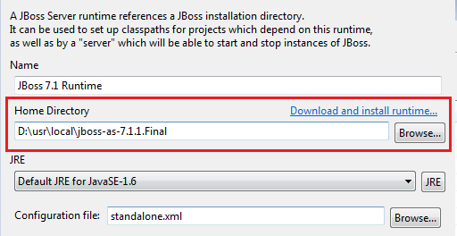

**Step 4:** To import project into Eclipse

After open the workspace, right click the space, and select “Import” -> “Import” at the menu

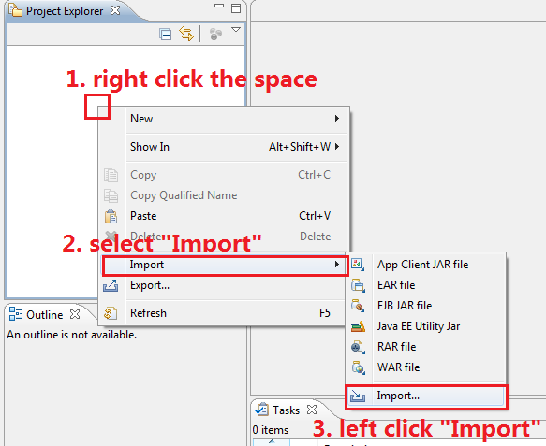

Select “Existing Projects into Workspace”

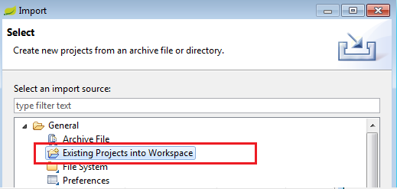

After that, follow below screen shoot comment, to import 1 project into your workspace.

You need to unzip the .zip file from “5. Source Code”

1. ntu-is-ead-tera-v2: war project about version 2.

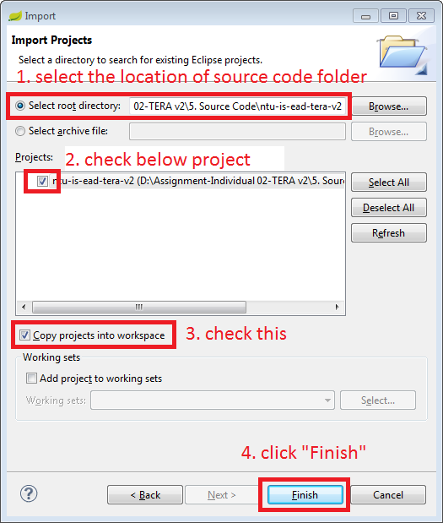

Once it is OK, it should look like as below:

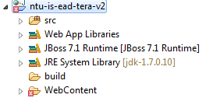

Please make sure that it is no build path error, otherwise after deploy to JBOSS will not successful to boot up the application.

**Step 5:** To Export project (WAR) into JBOSS

Right click project: ntu-is-ead-tera-v2, click Export -> WAR file

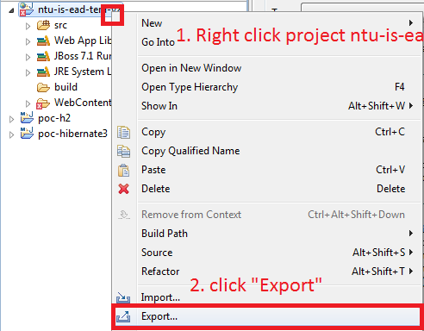

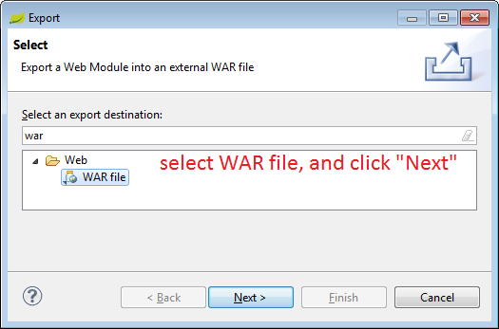

Browse to your JBOSS installation folder\standalone\deployment.

The exported EAR name must be: **ntu-is-ead-tera-v2.war**

After that you can click the option of “Overwrite existing file” and click “Finish”

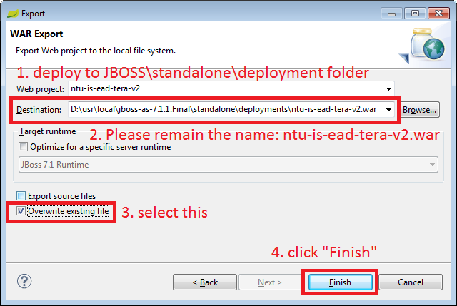

## 3.6 Run Application Server

Open command line, cd to your JBOSS installation folder\bin, such as



Key in command: **standalone**, you should see below message from command line console:

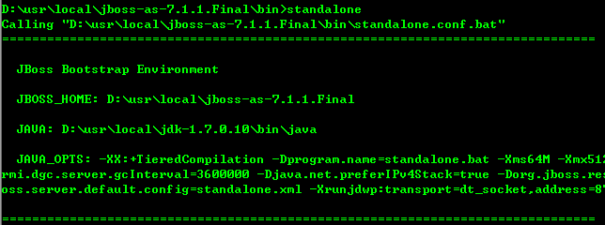

If successful, in console you can see:



At your JBOSS installation folder\standalone\deployment, you can see:



# 4. Validation

Open web browser, key in URL:

<http://localhost:8080/ntu-is-ead-tera-v2>

You should see below screen

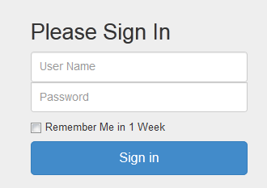

Key in User Name: isadmin, Password: root, and click “Sign in”, you should can see:

